Second Grade
3-Digit Addition and Subtraction
Section 1: Addition

Table of Contents
Topic | Suggested Number of Days | Page No.
Part 1: Finding Sums Using Place Value  Part 2: 3-Digit Addition Algorithm without Regrouping  Part 3: 3-Digit Addition Algorithm--Regrouping Decision  Part 4: 3-Digit Addition Algorithm with Regrouping  from the Ones Place to the Tens Place  3-Digit Addition Practice Part 4  Part 5: 3-Digit Addition Algorithm with Regrouping  from the Tens to the Hundreds Place  3-Digit Numeric Addition Cards  3-Digit Addition Partner Practice Part 5  Part 6: 3-Digit Addition Algorithm with Regrouping in  the Ones Place and the Tens Place  3-Digit Addition Partner Practice Part 6  Part 7: 3-Digit Addition Story Problems  3-Digit Addition Story Problems Guided Practice  3-Digit Addition Story Problems Partner Practice Part 7  Additional Materials:  Three-Fourths Grid Paper  Rubric | 1 day (1/6)  ½ day (1/7)  ½ day (1/7)  ½ day (1/8)  1 ½ days (1/8 – 1/9)  1 ½ days (1/12 – 1/13)  1 ½ days (1/13 – 1/14) | 2  4  5  6  13  14  18  19  20  23  24  26  28  30  31

Addition of 3-Digit Numbers
With and Without Regrouping

TEKS 2.4A recall basic facts to add and subtract within 20 with automaticity

TEKS 2.4C solve one-step and multi-step word problems involving addition and subtraction within 1,000 using a variety of strategies based on place value, including algorithms

TEKS 2.1A apply mathematics to problems arising in everyday life, society, and the workplace
TEKS 2.1B use a problem-solving model that incorporates analyzing given information, formulating a plan or strategy, determining a solution, justifying a solution, and evaluating the problem-solving process and reasonableness of the solution
TEKS 2.1C select tools, including real objects, manipulatives, paper and pencil, and technology as appropriate, and techniques, including mental math, estimation, and number sense as appropriate, to solve problems
TEKS 2.1D communicate mathematical ideas, reasoning, and their implications using multiple representations, including symbols, diagrams, graphs, and language as appropriate
TEKS 2.1E create and use representations to organize, record, and communicate mathematical ideas
TEKS 2.1F analyze mathematical relationships to connect and communicate mathematical ideas
TEKS 2.1G display, explain, and justify mathematical ideas and arguments using precise mathematical language in written or oral communication

Vocabulary: add, addition, regroup, ones, tens, hundreds, put together, combine, total, altogether, together, sum, model drawing, unit bar, place value, expanded form, compose, decompose

Teacher Background

In this section, students will learn to add 3-digit numbers using their knowledge of place value. In Part 1, they will specifically use what they have already learned about representing numbers in expanded form and composing/decomposing numbers in order to find sums utilizing a less-traditional method as noted in the TEKS. Students who are having difficulty representing numbers in expanded form may need additional practice with manipulatives.
In Parts 2-6, students will apply their knowledge of ones/tens/hundreds to learn the addition algorithm. In the beginning, students will focus on learning the algorithm in conjunction with manipulatives. Then, story problems will be added to provide a real-life context.
Part 1: Finding Sums Using Place Value

Materials: IMN Resource
(MATH_2_A_2 3DIGIT ADDITION IMN_RES)
Partner or Independent Practice ~ 3-Digit Addition Practice
(MATH_2_A_3 3DIGIT ADDITION IP_RES)

1. Display the following problem:

132 + 241

Explain to students that we can find the sum by breaking apart each addend into hundreds, tens and ones by writing the numbers in expanded form.
132 + 241
100 + 30 + 2
200 + 40 + 1

Now explain that we can find the sum by first adding the hundreds, then the tens and finally the ones. When those values are combined, we have a total of 373.

132 + 241
100 + 30 + 2
200 + 40 + 1
300 + 70 + 3 = 373

2. Show students the problem below:
256 + 318

Guide students to find the sum of this addition problem using the method demonstrated above. First, decompose the addends by representing them in expanded form.
256 + 318
200 + 50 + 6
300 + 10 + 8

Next, add the hundreds, then the tens and finally the ones. Compose the number into a standard form of 574.

256 + 318
200 + 50 + 6
300 + 10 + 8
500 + 60 + 14 = 574

Have students compare the problems discussed so far. Ask them to share what they notice. If necessary, guide them to see that we were able to make another group of ten once the ones were added together.

3. Display this problem for the students:
573 + 145

Have students talk with an elbow partner about how they would solve this problem. Allow students to share their thoughts with the group. Choose students who feel comfortable with the process to explain to the class in their own words and/or write how to solve for the sum. The completed problem is shown below:
573 + 145
500 + 70 + 3
100 + 40 + 5
600 + 110 + 8 = 718

Once the class discussion is finished, students may record the work for this problem in their interactive math notebooks. A frame is provided in the IMN Resource (MATH_2_A_2 3DIGIT ADDITION IMN 2014_RES) which may be completed and glued on the right side their IMN.

Ask students to think about all three of the problems we have worked together. Have them discuss with you any likenesses as well as differences among these problems. If necessary, point out to students that they were able to make another group of a hundred
once the tens were added together in the last problem.

4. Partner or Independent Practice

Based on the needs of your students, have them complete 3-Digit Addition Practice Part 1 (MATH_2_A_ 3 3DIGIT ADDITION IP 2014_RES) with a partner or independently.

5. Interactive Math Notebook (IMN) Entry----Left side

Check for student understanding by having students complete the following problem (MATH_2_A_2 3DIGIT ADDITION IMN 2014_RES) independently and glue on the left side of their IMN.

Write the addends in expanded form and add.
________ + ________ + ________

________ + ________ + ________

+ + = ________
159

+ 234

Would you get the same sum if you added the ones first, then the tens and the hundreds last? Why or why not?

Part 2: 3-Digit Addition Algorithm without Regrouping

Materials: base ten blocks or virtual base ten blocks (such as those provided by the NLVM-National Library of Virtual Manipulatives)
place value mats
three-fourths inch grid paper (p. 30)

1. Teacher Models, Teacher Records

Display the following 2-digit addition problem and build the numbers using base ten blocks.
53 + 32

Next to the 2-digit problem, display the following 3-digit addition problem and build the numbers using base ten blocks.
53 + 32
153 + 132

Model the addition using the blocks for each problem. As each step is completed, simultaneously record the action. For example, put together the ones with the blocks and then record in the ones place on the problem, etc.

Ask students questions such as:

What do you see? What do you notice?
How is the process of solving the two problems alike?
How is the process of solving the two problems different?

Help students see the similarities between adding 2-digit numbers and adding 3-digit numbers with no regrouping.

2. Teacher and Students Model and Record

Together the students and teacher model with base ten blocks several 3-digit addition problems step-by-step and at the same time record on three-fourths inch grid paper. Model the correct alignment of the digits on the grid paper using a document camera if available. Stress to students the importance of keeping the numbers aligned.

Possible problems:
147 + 121
232 + 225
375 + 203

3. Partner Practice

Have students work with a partner to build and solve problems together. Grid paper should again be used to help students with the proper alignment of the numbers. Encourage students to “talk math” and work cooperatively with the manipulatives.

Possible problems:
214 + 135
301 + 128
154 + 312

Part 3: 3-Digit Addition Algorithm---Regrouping Decision

Materials: base ten blocks or base ten technology (NLVM)
place value mats
three-fourths inch grid paper (p. 30)

1. Show students the following 2-digit problems:
61 + 37
28 + 42
61 + 37

Discuss each problem one at a time and review the process of making the regrouping decision. For each problem ask:

Do we regroup or not?
How did you know?
What questions can we ask ourselves to help us decide if regrouping is needed?

Remind students, if necessary, that regrouping is needed when there are 10 or more ones.
Questions to help us decide are: Less than 10?
10 or More?

2. Show students the 3-digit addition problem shown below covering up the digits in the hundreds place so that it looks like another 2-digit problem.
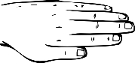
137 + 154
137 + 154

Do we regroup or not?

Once students have made their decision, reveal the digits in the hundreds place. Lead students to the connection that the regrouping decision in the ones place is made the same way in 3-digit problems as it is in 2-digit problems. Regrouping is needed whenever there are 10 or more ones.

Part 4: 3-Digit Addition Algorithm with Regrouping from the Ones Place to the Tens Place

Materials: base ten blocks or base ten technology (NLVM)
place value mats
three-fourths inch grid paper (p.30)
3-Digit Pictorial Addition Cards
student copies of 3-Digit Addition Practice Part 4
rubric for manipulative use (p. 31)

1. Teacher Models, Teacher Records

Display the problem and represent the numbers, 145 and 126, with base ten blocks as shown in the picture.

1 4 5
+ 1 2 6

Point to the ones place and ask students the following questions:

Do we have 10 or more? yes
How many ones do we have? 11

That’s the same as 1 group of ten and 1 one. Let’s take 10 ones and regroup them to make another group of ten. We can then put it with the other tens.

Emphasize that the ten is given to the tens place and not to the hundreds place.

1
1 4 5
+ 1 2 6
2 7 1

.

The one block that did not get regrouped is recorded. The tens and hundreds are then counted and recorded respectively.

2. Students and Teacher Model, Teacher Records

Students now model the algorithm using the base ten blocks along with the teacher, but only the teacher records the algorithm.

Possible problems:
238 + 27
314 + 208
129 + 561

3. Students and Teacher Both Model and Record

Teacher guides students through the building of the numbers and recording of the algorithm. It is recommended that the three-fourths inch grid paper be used when writing the problems in order to keep the numbers aligned. Once again, model the correct alignment of the digits on the grid paper using a document camera if available.

Possible problems:
345 + 215
148 + 36
402 + 139

4. Group Practice

Teacher projects the large 3-Digit Addition Pictorial Cards one at a time. Students signal with a thumbs up if regrouping is necessary or thumbs down if regrouping is not needed in the problem shown. Ask students to justify their responses and share their thinking with the group.

5. Partner or Independent Practice

Based on the needs of your students, have them complete 3-Digit Addition Practice Part 4 with a partner or independently. Students should use base ten blocks when solving these problems. If working with a partner, both students should be actively engaged with the manipulatives.

As students use the base ten blocks to solve problems, the teacher should use the rubric provided on page 31 to evaluate students’ understanding and progress.

3-Digit Pictorial
Addition Cards

+

3-Digit Pictorial
Addition Cards

+

+
+

3-Digit Pictorial
Addition Cards

+

3-Digit Pictorial
Addition Cards

+

3-Digit Addition Practice Part 4
Students should use base ten blocks when completing these problems.

Name _______________________

2 3 8
+ 1 5 5

3 7 7
+ 1 7

4 2 6
+ 2 3 3

1 6 6
+ 2 2 6

3 0 8
+ 4 1

3 6 5
+ 2 1 8

4 3 9
+ 1 2 0

1 2 9
+ 3 1 5

2 4 5
+ 3 2 6

Part 5: 3-Digit Addition Algorithm with Regrouping from the Tens Place to the Hundreds Place

Materials: base ten blocks or virtual base ten blocks (NLVM)
place value mats
three-fourths inch grid paper (p.30)
3-Digit Numeric Addition Cards
student copies of 3-Digit Addition Partner Practice Part 5
rubric for manipulative use (p. 31)
Independent Practice ~ 3-Digit Addition Independent Practice Part 5
(MATH_A_4 3DIGIT ADDITION IP 2014_RES)

1. Teacher Models, Teacher Records

Display the problem and represent the numbers, 152 and 173, with base ten blocks as shown in the picture.

1 5 2
+ 1 7 3

Point to the ones place and ask students the following questions:

Do we have 10 or more? no
So what do we do? put them together

The ones are combined, and the total is recorded in the ones place.

Now, cover the ones place with your hand or a strip of paper so students are able to focus only on the tens place. Point to the tens place and ask students these questions:

How many tens do we have? 12 tens
Do we need to regroup the tens to make a group of a hundred? (Have students signal with a thumbs up if they feel regrouping is necessary and a thumbs down if regrouping is not needed.)
How many tens do we need to make a group of a hundred?
Let’s build it to find out. (Place rods on a hundreds flat to show that it takes 10 tens to make a group of a hundred).

So, what is the value of 10 tens? 100
Since we have more than 100 what do we do? regroup the 10 tens to make another group of a hundred
We can then put it with the other hundreds.

Guide students to realize that the regrouping decision for the tens is very similar to making a decision about regrouping with the ones. We can ask ourselves the question, “Do we have 100 or more?”

1
1 5 2
+ 1 7 3
3 2 5

The 2 tens that did not get regrouped are recorded. Count and record the 3 hundreds.

2. Students and Teacher Model, Teacher Records

Students now manipulate the blocks along with the teacher. The teacher records as the class proceeds through the algorithm.

Possible problems:
281 + 165
172 + 143
359 + 290

3. Students and Teacher Both Model and Record

Students now join the teacher in recording the algorithm. Again, it is recommended that the three-fourths inch grid paper be used.

Possible problems:
244 + 182
357 + 150
196 + 423

4. Partner Practice

Students work with a partner to sort the 3-Digit Numeric Addition Cards into groups, one for those that need regrouping and one for those that do not need regrouping. Students may use the base ten blocks to assist with their decision if necessary.
Students continue their partner practice with 3-Digit Addition Partner Practice Part 5. Students should use base ten blocks when solving these problems. Both students should be actively engaged with the manipulatives. Once again, the rubric may be used to evaluate students’ understanding and progress.

5. Independent Practice

Students complete 3-Digit Addition Independent Practice Part 5
(MATH_2_A_4 3DIGIT ADDITION IP 2014_RES) independently. Based on students’ needs, the teacher may adjust the number of problems worked by the students. Base ten blocks should also be available for use.

3-Digit Numeric
Addition Cards
Less than 100? OR 100 or more?

186
+ 372
341
+ 173

293
+ 205
356
+ 271

198
+ 261
232
+ 384

153
+ 212
225
+ 264

347
+ 372
127
+ 82

268
+ 370
216
+ 481

3-Digit Addition Partner Practice Part 5
Students should use base ten blocks when completing these problems.

Name ___________________

2 7 0
+ 1 6 2

1 5 2
+ 2 8 5

2 5 5
+ 2 4 2

1 7 3
+ 3 5 4

1 4 1
+ 8 3

2 0 4
+ 1 9 5

1 6 3
+ 2 4 4

1 2 6
+ 1 4 3

3 8 0
+ 1 9 4

Part 6: 3-Digit Addition Algorithm with Regrouping from the Ones Place and the Tens Place

Materials: base ten blocks or virtual base ten blocks (NLVM)
place value mats
three-fourths inch grid paper (p.30)
student copies of 3-Digit Addition Partner Practice Part 6
rubric for manipulative use (p. 31)
Independent Practice ~ 3-Digit Addition Independent Practice Part 6
(MATH_2_A_5 3DIGIT ADDITION IP 2014_RES)
IMN Resource (MATH_2_A_6 3DIGIT ADDITION IMN 2014_RES)

1. Teacher Models, Teacher Records

Display the problem and represent the numbers, 254 and 169, with base ten blocks as shown in the picture.

2 5 4
+ 1 6 9

Point to the ones place and ask students the following questions:

Do we have 10 or more? yes
So what do we need to do? regroup 10 ones to make another group of ten

Regroup 10 ones to make another group of ten. Place it with the other tens and record.

Point to the tens place and ask students these questions:

Do we have 100 or more? yes
So what do we need to do? regroup 10 tens to make another group of a hundred

Regroup 10 tens to make another group of a hundred. Place it with the other hundreds and record.

1 1
2 5 4
+ 1 6 9
4 2 3

2. Student and Teacher Model , Teacher Records

Students manipulate the blocks along with the teacher. Teacher records the algorithm for the group.

Possible problems:
138 + 75
266 + 148
382 + 259

3. Students and Teacher both Model and Record

Teacher guides students through the building of the numbers and recording of the algorithm. It is recommended that the three-fourths inch grid paper be used when writing the problems to keep the numbers aligned properly.

Possible problems:
217 + 194
156 + 77
302 + 298

4. Partner Practice

Students work 3-Digit Addition Partner Practice Part 6 with a partner using base ten blocks. Both students should be actively engaged, and the rubric may once again be used by the teacher if desired.

5. Independent Practice

Students complete 3-Digit Addition Independent Practice Part 6
(MATH_2_A_5 3DIGIT ADDITION IP 2014_RES) independently. Students should use base ten blocks to ensure a deeper understanding of the algorithm.

6. Interactive Math Notebook (IMN) Entry

Right side:

Work through the 3-digit addition problem
(MATH_2_A_6 3DIGIT ADDITION IMN 2014_RES) with your students using base ten blocks. Simultaneously, create a pictorial representation of the blocks and record the steps of the algorithm on the problem. “Think aloud” and question the students as you solve the problem together. Once complete, students may glue on the right side of their IMN. See picture below.
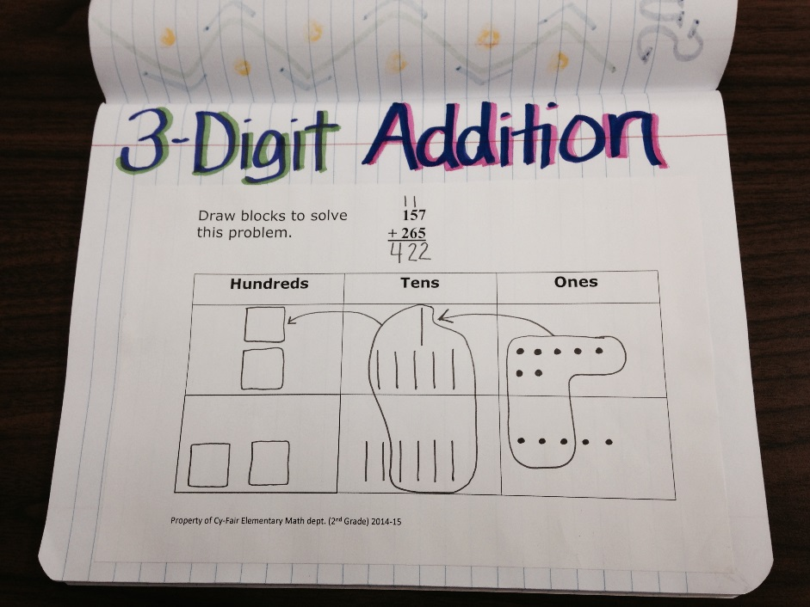

3-Digit Addition Partner Practice Part 6

Students should use base ten blocks when completing these problems.

Name _________________________

1 9 2
+ 2 3 8
2 7 8
+ 1 5 1
3 4 9
+ 5 6
1 5 4
+ 3 7 7
1 8 5
+ 2 0 5
2 3 7
+ 1 8 3
3 8 2
+ 1 6 8
2 6 6
+ 4 4
2 3 0
+ 1 1 2

Part 7: 3-Digit Addition Story Problems

Materials: base ten blocks or base ten technology
place value mats
three-fourths inch grid paper if needed (p. 30)
student copies of 3-Digit Addition Story Problems Guided Practice
student copies of 3-Digit Addition Story Problems Partner Practice Part 7
Independent Practice ~ 3-Digit Addition Story Problems Practice Part 7
(MATH_2_A_7 3DIGIT ADDITION STORY PROBLEMS IP 2014_RES)
IMN Resource (MATH_2_A_8 3DIGIT ADDITION IMN 2014_RES)

Teacher Background

Solving 3-digit addition story problems is very much like solving 2-digit addition story problems. The 4-step process mirrors what students have already been learning and practicing with 2-digit numbers. Help students see that they are able to use what they already know and extend that to problem situations involving addition of 3-digit numbers. Guided practice, partner practice and independent practice is provided. In these exercises, students focus on addition situations only so they may become more comfortable with them before they are mixed with subtraction story problems later.
Students should continue to use the base ten blocks when doing the algorithm. Have them draw a picture of the blocks in Step 3 as they did when adding 2-digit numbers.

1. Guided Practice

Work Guided Practice Problem #1 with students. Read the problem together, insert speed bumps and complete the 4-step process. Students who are still having difficulty aligning the digits in the numbers may continue to use the three-fourths inch grid paper.

Susan has 271 pennies. Alice has 147 pennies. How many pennies do Susan and Alice have altogether?

pennies altogether
Put together Added 271 and 147 to get a sum of 418.
271

S p

?
A p

147

ξ
ξ
1
2 7 1
+ 1 4 7
4 1 8

Work Guided Practice Problem #2 with students in a similar manner as above. The model drawing may be done correctly either using 1 unit bar or 2 unit bars depending on how students “see” the problem.

2. Partner Practice

Students work with a partner to complete 3-Digit Addition Story Problems Partner Practice Part 7. Again, base ten blocks should be used and both partners actively engaged in the process. The teacher may also choose to use the rubric for manipulative use on page 31.

3. Independent Practice

Students complete 3-Digit Addition Story Problems Practice Part 7
(MATH_2_A_7 3DIGIT ADDITION STORY PROBLEMS IP 2014_RES) independently. Students should use base ten blocks to strengthen their understanding of the algorithm.

4. Interactive Math Notebook (IMN) Entry

Left side:

Have students create their own 3-digit addition problems. First, students write a problem that does not involve regrouping. Then, they write a problem in which regrouping is needed. Students are not writing story problems at this time. Problem frames are provided in the IMN resource
(MATH_2_A_ 8 3DIGIT ADDITION IMN 2014_RES).

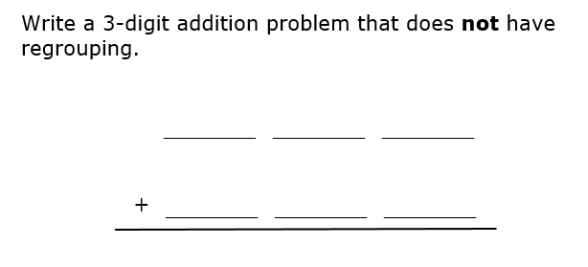

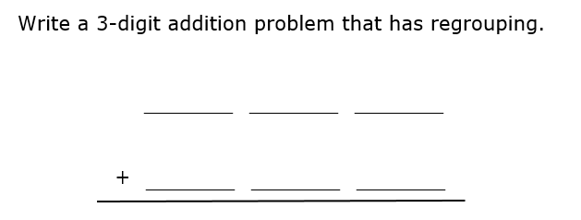
3-Digit Addition Story Problems Guided Practice

1. Susan has 271 pennies. Alice has 147 pennies. How many pennies do Susan and Alice have altogether?

2. Nick has 186 purple marbles and 235 blue marbles. How many purple or blue marbles does Nick have?

3-Digit Addition Story Problems Partner Practice Part 7

1. Alexis and Myra are collecting box tops for school. Alexis collected 145 box tops, and Myra collected 192. How many box tops did the 2 girls collect?

4. Gage was playing video games. On his first game he scored 265 points. On his second game he scored 287 points. How many total points did Gage score on his two games?

Name____________________________

Using Base Ten Blocks for 3-Digit Addition/Subtraction
With/Without Regrouping

Objective | 4 | 3 | 2 | 1
Uses manipulatives to demonstrate the process of 3-Digit Addition and Subtraction with and without regrouping | The student is able to manipulate the blocks correctly without teacher help. | The student is able to manipulate the blocks with only a few mistakes, but is able to  self-correct when they are pointed out. | The student is able to manipulate the blocks with mistakes and needs help to correct the mistakes. | The student is not able to manipulate the blocks correctly without teacher assistance.

31

