**Sixth Grade Unit Test**

**Energy: Test 2**



1. A gasoline powered vehicle goes up a hill from point X to point Y. What energy transformation must occur in the car’s engine?

A. chemical energy into mechanical energy

B. electrical energy into chemical energy

C. thermal energy into chemical energy

D. mechanical energy into nuclear energy

2. Which of these energy resources will most likely be depleted first?

A. Wind

B. Solar energy

C. Fossil fuels

D. Water

3. Many toys and household items get power from batteries. Which of the following transformations, or changes, takes place in a battery?

A. Electrical energy is transformed into mechanical energy and thermal energy.

B. Chemical energy is transformed into electrical energy and thermal energy.

C. Mechanical energy is transformed into thermal energy.

D. Thermal energy is transformed into chemical energy.

4. A student pours lemonade from a pitcher into a glass. Which of the following best describes the change in the liquid’s energy as it falls toward the glass?

A. The liquid gains both potential and kinetic energy.

B. The liquid loses kinetic energy as it gains potential energy.

C. The liquid’s potential energy is changed into kinetic energy.

D. The liquid’s potential and kinetic energy combine to form gravitational kinetic energy.



5. The picture above shows a radiometer. It is designed to be placed in a sunny window. One side of each thin blade of the radiometer is painted black and the other side is painted white. The sun’s rays strike the blades and the device begins to spin. The device demonstrates what kind of energy transformation?

A. elastic to mechanical

B. mechanical to electrical

C. electrical to magnetic

D. electromagnetic to mechanical

6. Which of the pictures below shows electromagnetic energy converted to chemical energy?

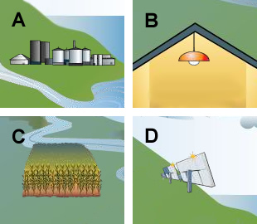

corn

solar panel

power plant

light bulb

7. What is the main advantage of using hydroelectric power plants to generate electricity?

A. They can be built near most cities.

B. They do not produce much pollution.

C. They are inexpensive to build.

D. They do not damage wildlife habitat.

8. Which statement below is an example of energy conservation by reducing consumption?

A. Walk instead of driving a car so not as much oil will need to be pumped from the ground.

B. Create a compost pile of discarded fruit and vegetable materials.

C. Use a margarine tub to hold coins in a desk drawer.

D. Make an art project out of recycled paper, plastic containers, aluminum and glass.

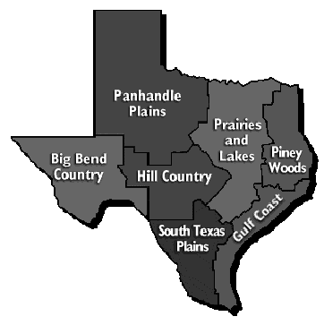

9. The climate in the Big Bend region of Texas is hot, windy and dry. What forms of renewable energy sources would be the best fit for this region of the state?

A. wind and natural gas

B. geothermal and solar

C. hydroelectric and coal

D. wind and solar

10. Tyrone said that the advantages of using coal were that it was cheap to get out of the ground, easily replaced by the Earth and is considered a clean fuel to burn. Jackson thought that geothermal was a better choice because it is cheap, considered a clean fuel and is easily replaced by the Earth. Which student is correct?

|  |  |
| --- | --- |
| A. | Both students are correct. |
| B. | Both students are incorrect. |
| C. | Tyrone is correct. |
| D. | Jackson is correct. |

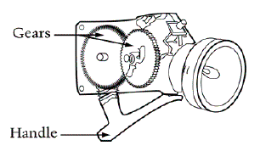11. Look at the diagram below. It shows a flashlight that has no batteries and works by squeezing and letting go of the handle. Inside the body of the flashlight are gears, which are shown below.

Which sequence best identifies the energy transformations that take place within the flashlight to produce light?

A. mechanical → chemical → light

B. mechanical → electrical → light

C. chemical → mechanical → light

D. chemical → electrical → light



12. A student is comparing the potential energy of four tennis balls of the same mass. Due to its position, which tennis ball has the greatest gravitational potential energy?

A. Ball 1

B. Ball 2

C. Ball 3

D. Ball 4

13. A gasoline engine only converts about 15% of the chemical energy of gasoline into mechanical energy. What other energy transformation is taking place in the gasoline?

A. chemical to thermal

B. nuclear to chemical

C. electrical to thermal

D. mechanical to nuclear

14. A student is investigating potential and kinetic energy by stretching a spring across a table. When the student lets go, the spring recoils.

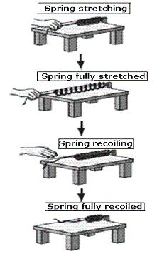

.

At which time is potential energy in the spring being converted into kinetic energy in this system?

A. When the spring is stretching.

B. When the spring is fully stretched.

C. When the spring is recoiling.

D. When the spring is fully recoiled

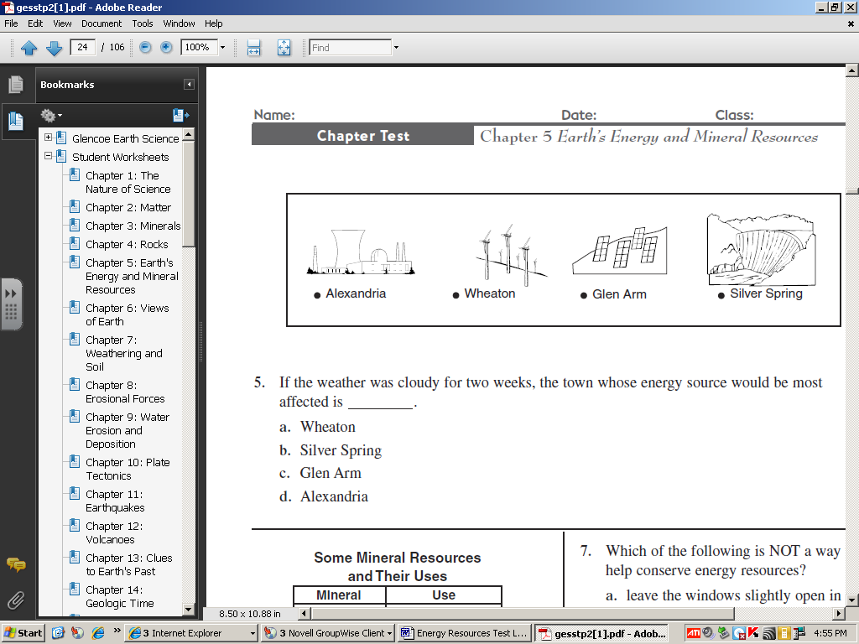

15. If the weather was cloudy for two weeks, which town’s energy source would be most affected?

A. Wheaton

B. Silver Spring

C. Glen Arm

D. Alexandria

16. To try and reduce costs, the power supply for a city was changed in June from 100% fossil fuels to use 50 % solar and 50 % gas. A scientist has been investigating whether the change has been successful. His observations are shown in the data table below.

| **Month of the Year** | **Cost of Power in Millions of Dollars** |
| --- | --- |
| March | 1.0 |
| April | 0.9 |
| May | 1.0 |
| June | 0.7 |
| July | 0.6 |
| August | 0.6 |
| September | 0.7 |

Which statement about his observations is true?

A. The cost appears to have gone up since an alternative energy resource was used.

B. The cost appears to have gone down since an alternative energy resource was used.

C. The change in power supply has made no difference in the cost of the power.

D. The city did not change to an alternative energy resource.

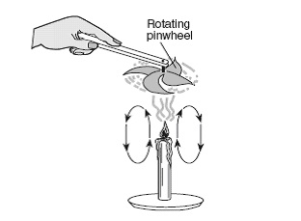17. The diagram below shows a pinwheel rotating above a lit candle. The arrows indicate the direction of air flow. Which energy transformation is best shown in this diagram?

A. thermal to mechanical

B. mechanical to electromagnetic

C. sound to thermal

D. thermal to sound

18. Before constructing a new power plant, the builders are required to prepare an environmental impact statement. This document describes the effect that the construction and operation of the power plant will have on the nearby area. Why is it important to prepare an environmental impact statement before building the power plant?

A. The statement will give the safety procedures for workers.

B. The statement helps the community protect its natural resources.

C. The statement will help the community plan for new housing developments.

D. The statement can be converted into a news article.

C:\Users\admin\AppData\Local\Microsoft\Windows\Temporary Internet Files\Content.IE5\85A9VPF0\MC900391294[1].wmf

19. What type of energy transformation occurs when using a blow dryer?

A. thermal → electrical → sound

B. electrical → sound → chemical

C. electromagnetic → mechanical → nuclear

D. electrical → mechanical → thermal

20. Coal has an important advantage over many other sources of energy because it is easy to transport.

Which of the following statements are disadvantages of coal?

I. Coal is a nonrenewable source of energy.

II. When burned, coal increases the amount of carbon dioxide in the atmosphere.

III. After a coal mine is closed, repairs are needed in the environmental area.

A. Statement I

B. Statement II

C. Statements II and III

D. Statements I, II, and III