Science Fourth Grade Unit Test
Forces, Motion, and Machines
Part Six
MODIFIED

Choose the best answer for each question.

Use the diagram to answer question 1.

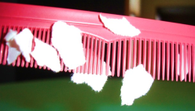
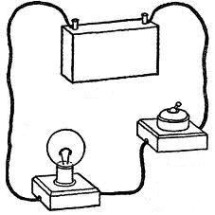
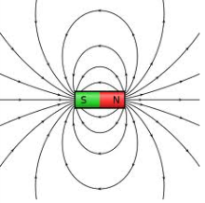
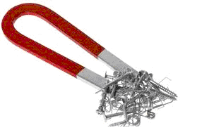
Electricity
Magnetism
?

1. Which picture belongs in the middle of the Venn diagram?

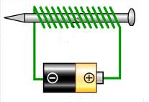
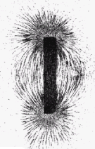
A.
C.

B.
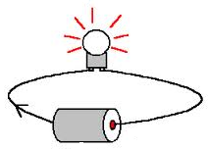

2. Which of the magnets are labeled correctly?

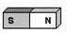
Attract
Attract
Attract

A.

Attract
Repel
Repel

B.

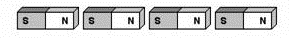
Attract
Attract
Attract

C.

3. Nathan skated from his house to the supermarket.

During which part of the trip did his inline skates experience the LEAST amount of friction?

- on the loose gravel of the driveway
- through the grassy lot
- on the new concrete between Cedar and Crosby Streets

4. What forces are being used by the dog?

A. The dog is pushing on the rope and pulling on the ground.
B. The dog is pushing on the rope and the ground.
C. The dog is pulling on the rope and pushing on the ground.

5. A skateboarder pushes on the ramp with his foot to start down the ramp.

How did gravity affect the skateboard?
A. Gravity slowed the skateboard down.
B. Gravity made the skateboard speed up.
C. Gravity made the skateboard start moving.

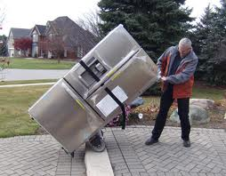
Use the diagram below to answer question 6.

6.
- A man is using a hand truck to drag a new refrigerator on his driveway.
- The drive way is made up of a rough stone with small sections of smooth asphalt.

Explain what happens when the man reaches a section of smooth asphalt.

A. Gravity is reduced because smooth surfaces require less gravity.
B. Friction is reduced because less force is used to move the refrigerator.
C. Magnetism is increased because of the amount of metal in the refrigerator.

7. The students rolled a toy car down a ramp from three different heights.

The results are shown in the table.

 | Trial 1 | Trial 2 | Trial 3
10 cm | 10 sec | 9 sec | 10 sec
20 cm | 7 sec | 8 sec | 8 sec
30 cm | 4 sec | 4 sec | 5 sec

What conclusions can be drawn from this investigation?

A. The car on the shortest ramp took the least amount of time because it didn’t have as far to travel.
B. The car on the medium ramp had the most speed because it took the least amount of time.
C. The car on the tallest ramp had more speed because of the height of the ramp.

8.
- In a race, each swimmer goes the same distance.
- The swimmer who goes the distance in the least amount of time wins the race.

This person has the greatest _________.
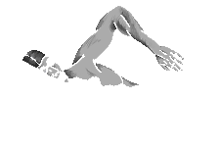
A. friction
B. gravity
C. speed

9. Which of the following pictures does NOT show an example of acceleration?
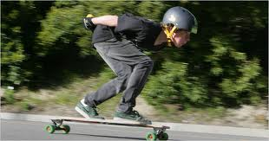
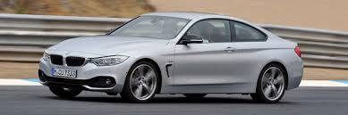
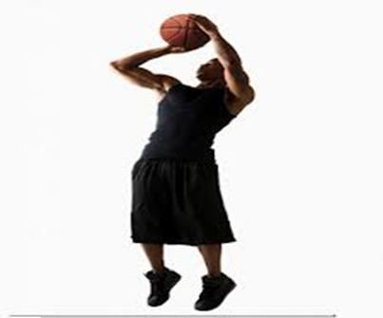
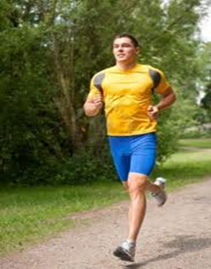
a skateboarder riding down the side of a hill
a car going 55 miles per hour on a highway
a basketball player slowing down to take a shot
A.
B..
C.

10. A student wants to pick up a heavy object with a magnet.

Which picture shows the object being attracted to the weakest part of the magnet?

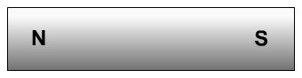
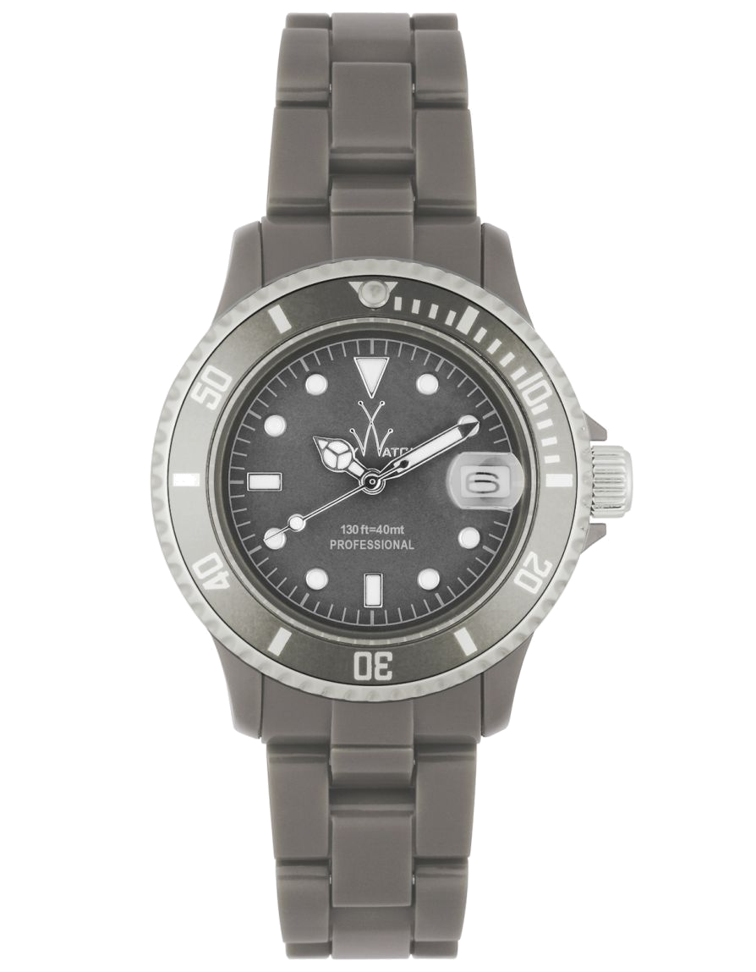
A. C.

B. D.

11. Which of the following electromagnets would have the greatest magnetic
field?
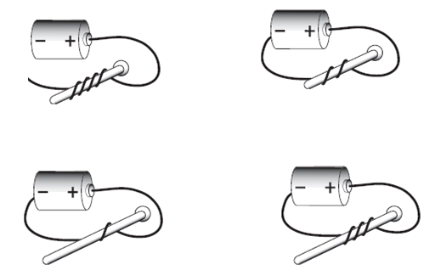
A. C.

B. D.

Use the table to answer question 12.

Column A | Column B
using wheels to move a heavy object | sliding down the slide in shorts
playing soccer in cleats | skating on gravel
? | driving through deep mud
bicycle brakes rubbing the wheel to stop | ?

12. Which of the following examples of friction belongs in Column A?

A. riding in the grass instead of on smooth concrete
B. moving furniture across the carpet
C. having chains on your tires during an ice storm

Use the following information to answer questions 13 and 14.

- A young boy was riding his bike and heard a rough, scraping sound.
- It looked like his chain was rubbing against another piece of metal and it was slowing him down.

13. What could the boy do to stop the scraping sound?

A. He could ride his bike more slowly.
B. He could place some oil in the area where the two pieces of metal are rubbing.
C. He could replace his current bike seat with a new one.
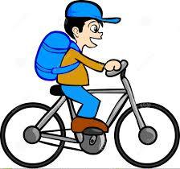

14. How is the boy’s ability to ride his bike affected?

A. There is an increase in gravity which slows the bike down.
B. There is a decrease in magnetism which speeds the bike up.
C. The two pieces of metal are causing friction which slows the bike down.

15. Which of the following simple machines is NOT used as a wedge?

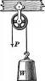
A. C.
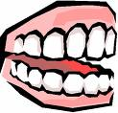

B.
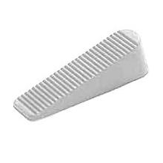

Use the pictures below to answer question 16.

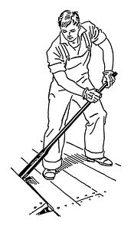
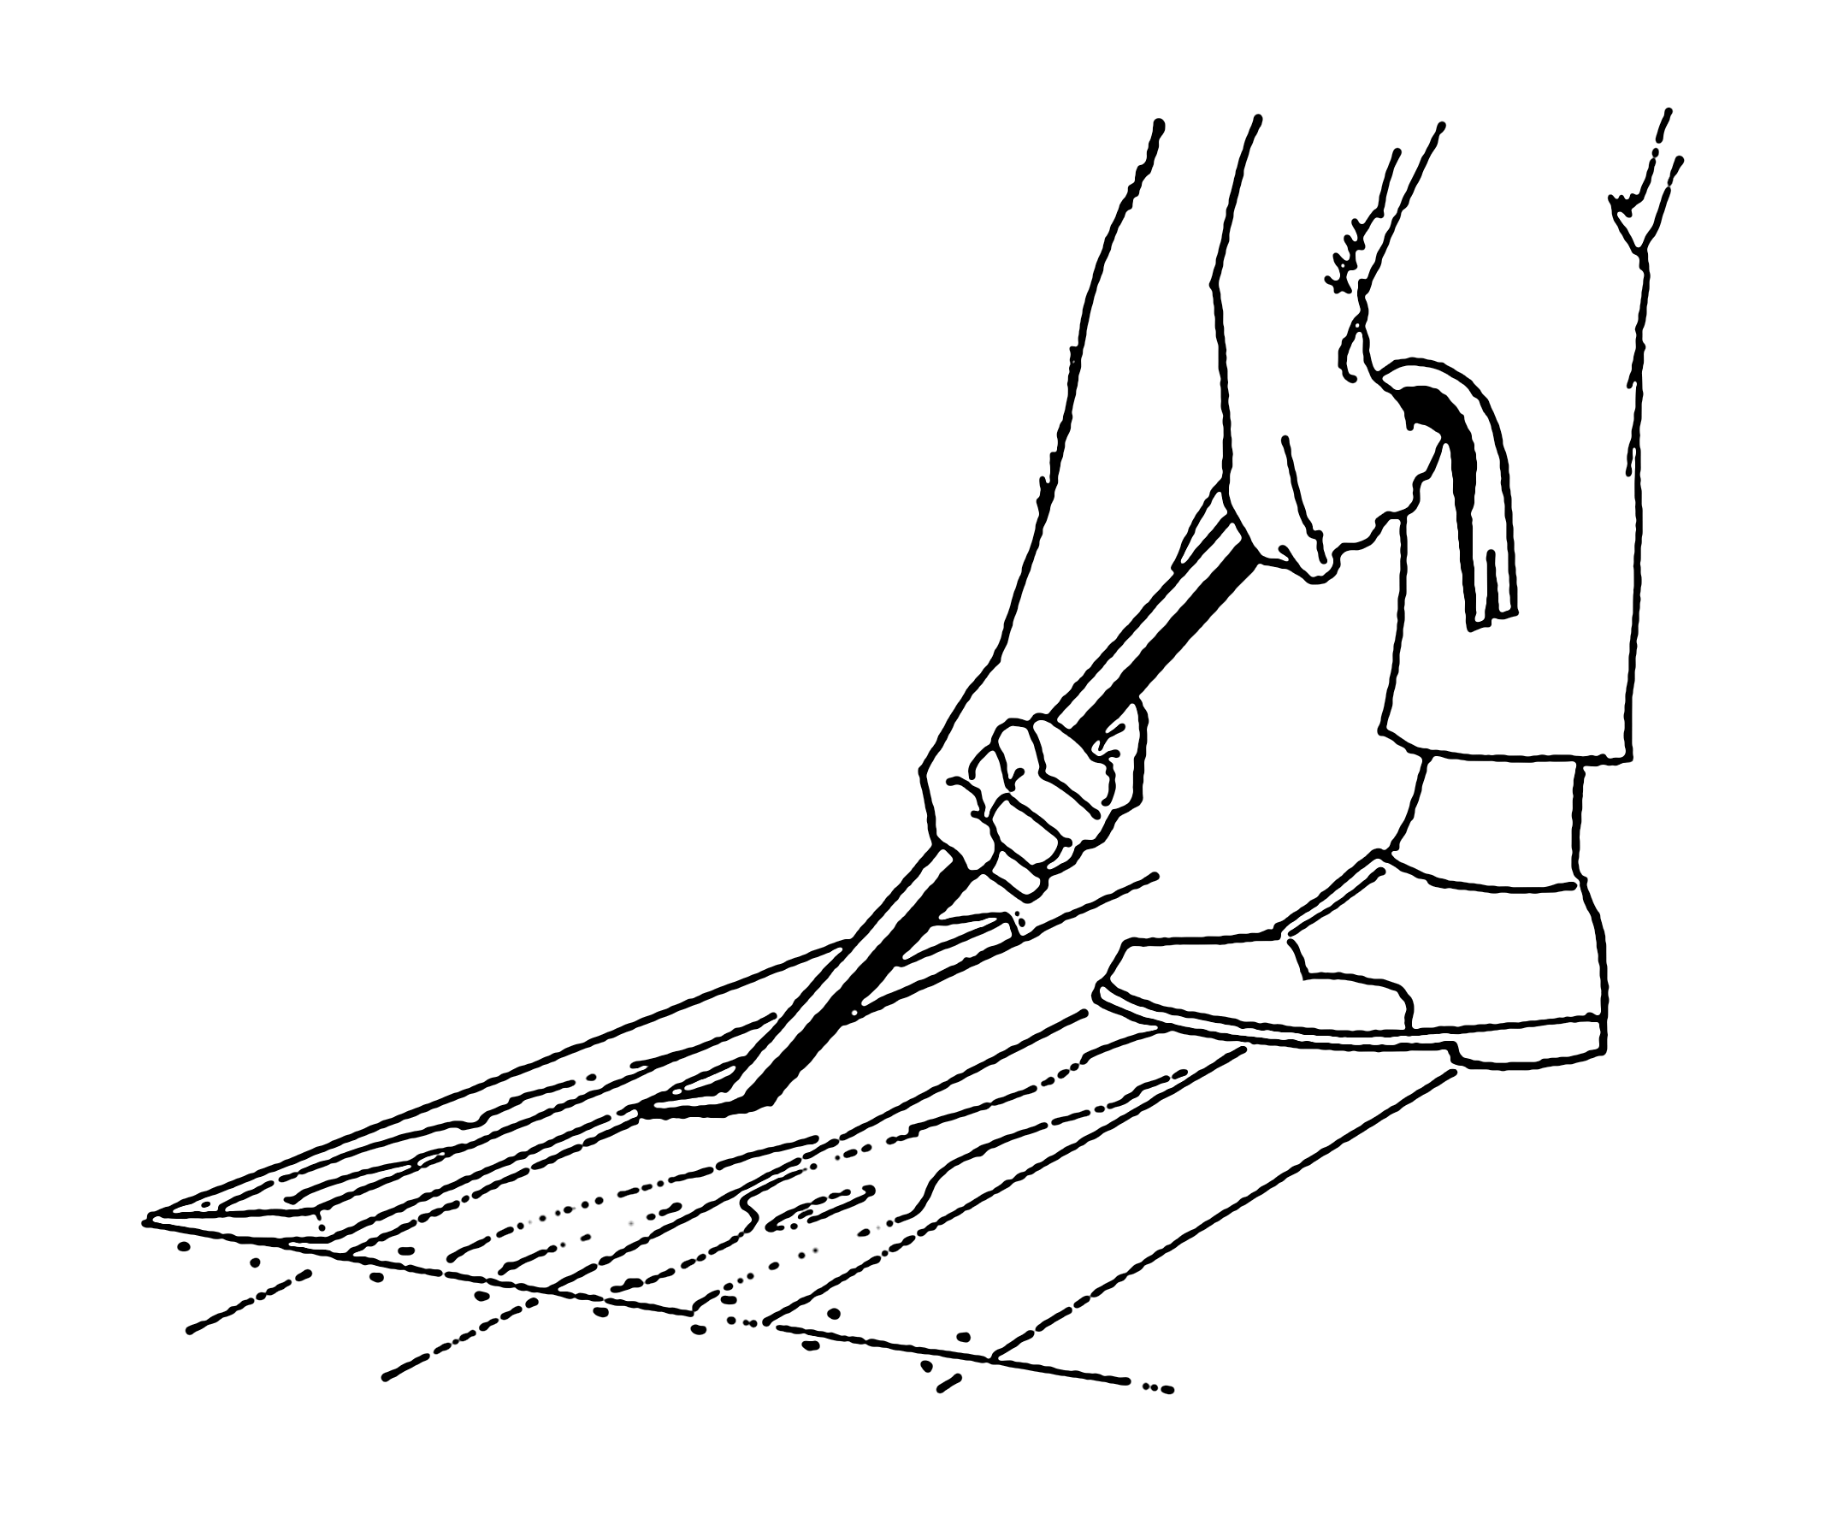

16. The man in the picture is using a crow bar to lift a board.

The crow bar could be called a _____________________.

A. wedge and a lever
B. wedge and a screw
C. lever and a pulley

Use the chart to answer question 17.

paperclip | yes
cork | no
paper | no
nail | yes
pencil | no
soda can | no

17. What problem was the scientist trying to solve?

A. Will these items be attracted to a magnet?
B. Will gravity affect these items if they were moved to the moon?
C. Will these items float in water?

Use the diagram to answer question 18.
Student 2

22
Student 3

7
Student 1

12
Time in minutes

18. If each of the students ran the same distance, which student had the greatest speed?

A. Student 1
B. Student 2
C. Student 3

19. What part of this diagram represents an input force?

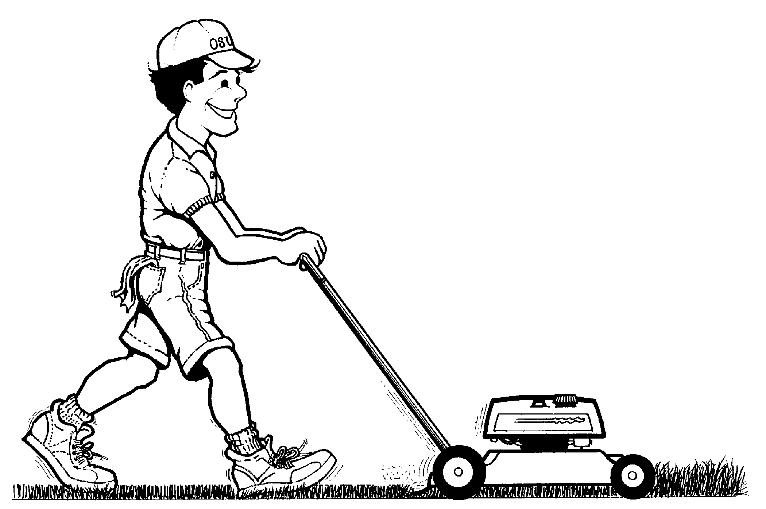
A. the wheels moving on the lawn mower
B. the engine running
C. the man pushing the handle

Use the diagram to answer question 20.

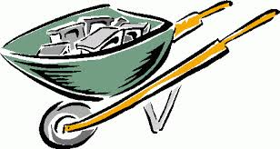
A
C
B

20. What are the names for the parts labeled below in the diagram?
.
.
.

AfulcrumBinput forceCload

Ainput forceBloadCfulcrum
AloadBinput forceCfulcrum
A.
B.
C.

21. Girl B is pushing down on the seesaw.
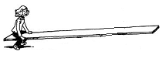
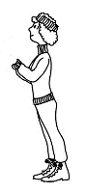
Girl A
Girl B
What is the output force in this system?

A. girl A moving down toward the ground
B. girl A moving up away from the ground
C. the seesaw balancing

22. What two simple machines are in this diagram?

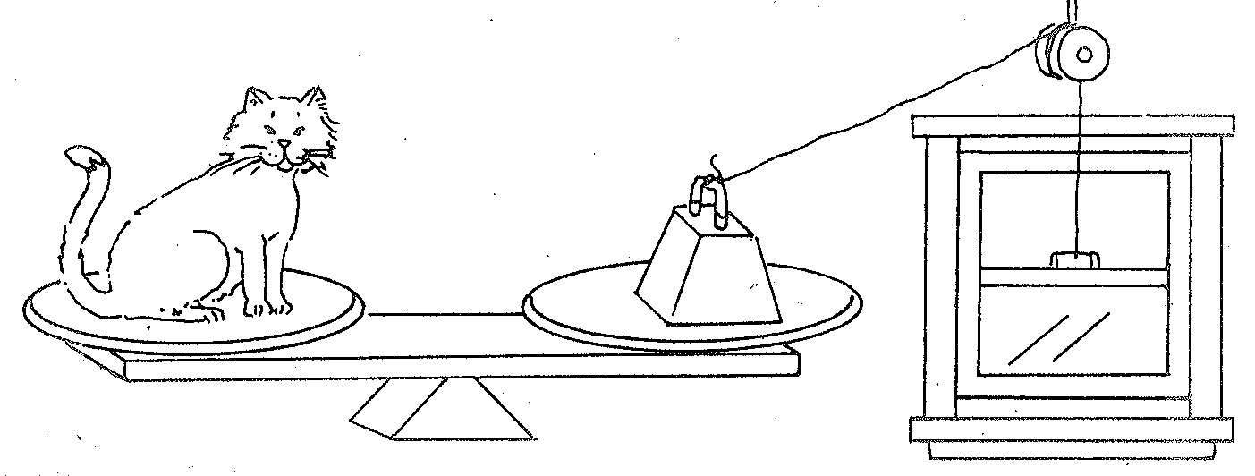

A. inclined plane and pulley
B. pulley and wedge
C. pulley and lever

23. What does this diagram represent?

A. magnetic field
B. temporary magnet
C. electromagnet

24. Scissors are an example of a compound machine.

Which of the following simple machines are combined to make scissors?
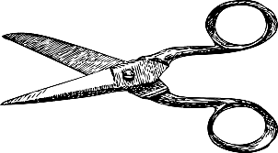
A. lever and wedge
B. wedge and pulley
C. wedge and inclined plane

Use the pictures below to answer question 25.

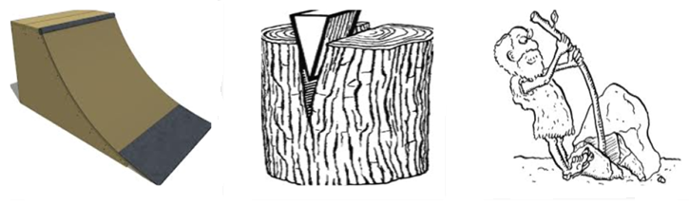

25. Which of the following lists the simple machines in the order shown above?

A. lever, wedge, wheel and axle
B. inclined plane, lever, wedge
C. inclined plane, wedge, lever

- What will happen to the box if the boy lets go of the rope?

A. The box will swing back and forth.
B. The box will move up.
C. The box will move down.

Use the chart below to answer question 27.

Column A Column B
faucet handle | ramp
door knob | sliding board
skateboard wheels | ladder
steering wheel | staircase

27. What could be a possible title for Column B?

A. Simple Machines that do not move
B. Simple machines that turn on a fixed point
C. Simple Machines that have a wheel attached to a rod

28. What affects the direction a compass needle points?
N
S
E
W

A. the direction the person holding the compass is facing
B. the direction the person holding the compass wants to go
C. the direction of Earth’s north magnetic pole

29. A worker is carrying a load of rocks in his wheelbarrow and it is getting increasingly difficult to lift.
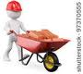
Which is NOT a way to make it easier to lift the load?

A. Remove all the rocks from the wheel barrow.
B. Remove the rocks and replace them with an equal weight of water.
C. Move the load of rocks closer to the fulcrum.

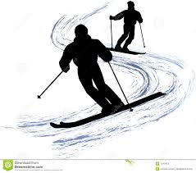
- What two forces are evident in this diagram?

A. magnetism and friction
B. friction and gravity
C. gravity and magnetism
.

31. A man needs to move the refrigerator up a step into the kitchen.

Which lever would the man need to use to do the LEAST amount of work?

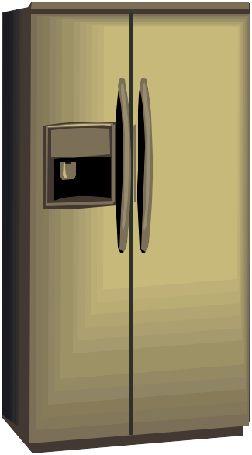

A. C.

B.

- Which of the following is an example of work?
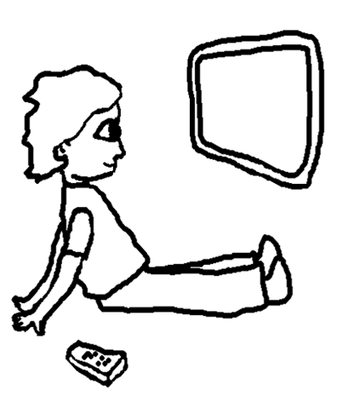
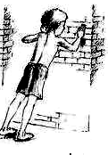
A. C.

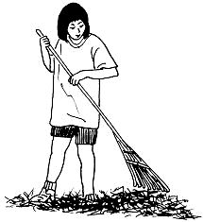
B.

33. If the man pushed the wheelbarrow to the end of the line, which picture would show the most work being done?
20 feet
Loaded with rocks
A. C.
10 feet
No load

B.
5 feet
No load

